**1.1 A Brief History of Neuropsychology**

* Franz Gall: phrenology; associated development of a trait with growth of its relevant part of the brain
* Pierre Fluorens: extirpation/ablation; concluded that different brain regions have specific functions
* William James: “father of American psychology”; pushed for the importance of studying adaptations of the individual to his or her environment
* John Dewey: credited with the landmark article on functionalism; argued for studying the entire organism as a whole
* Paul Broca: correlated pathology with specific brain regions, such as speech production from Broca’s area
* Hermann von Helmholtz: measured speed of a nerve impulse
* Sir Charles Sherrington: inferred the existence of synapses

**1.2 Organization of the Human Nervous System\***

Central and Peripheral Nervous System

* Refer to Biology Review: Chapter 4

The Autonomic Nervous System

* Refer to Biology Review: Chapter 4

**1.3 Organization of the Brain\***

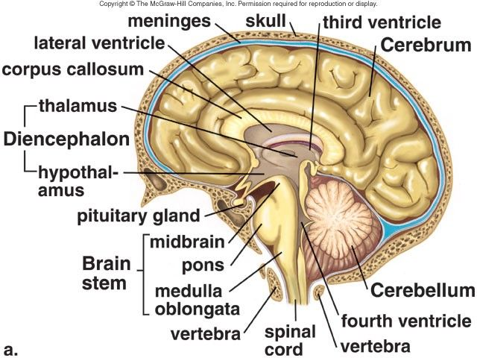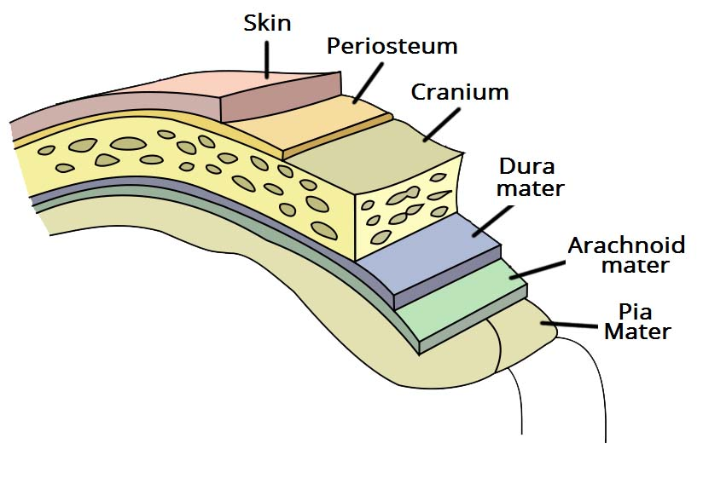

**Meninges**

* Dura mater: outer layer lining skull
* Arachnoid mater: contains blood vessels
  + Subarachnoid mater: filled with CSF
* Pia Mater: covers brain

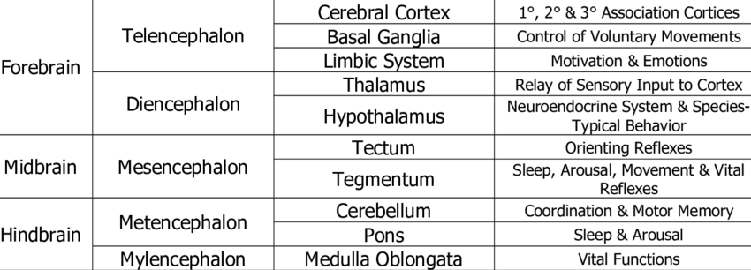

* **Reticular formation** (distributed gray matter in the brainstem): participates in many **autonomic** functions e.g. circulation, respiration, and digestion; **arousal** and **alertness**

Hindbrain (rhombencephalon)

* Manages vital functions necessary for **survival**
* Divides to form:
  + Mylencephalon
    - Medulla oblongata: Regulates breathing, heart rate, and blood pressure
  + Metencephalon
    - Pons: Sleep and arousal
    - Cerebellum: Coordinates and refines movement
      * **Motor Plan** (info is delivered from cerebrum to cerebellum while movement is being executed by UMN)
      * **Position Sense** (brainstem and cerebellum know if they are going according to plan, and if feedback is needed)
      * **Feedback** (cerebellum sends feedback back to motor areas of cerebrum → change activity of UMN to correct movement)

Midbrain (mesencephalon)

* Associated with **involuntary reflex** responses triggered by visual or sensory stimuli
* Two prominent nuclei:
  + **Superior** colliculus: receives visual sensory input
  + **Inferior** colliculus: receives sensory information from the auditory system

Forebrain (prosencephalon)

* Associated with complex perceptual, **cognitive**, and **behavioural** processes
* Associated with **emotion** and **memory**

1. Telencephalon
   1. Cerebral cortex (or neocortex): Most recent brain region, with gyri and sulci
      1. Frontal lobe
         1. **Prefrontal cortex**: **Executive** function + **association area** (as compared to projection areas that perform simpler tasks e.g. visual cortex, motor cortex)
         2. **Motor cortex**: Projection area → initiates voluntary motor movements by sending impulses to muscles (organization pattern visualized through **motor homunculus** - some muscles require finer control, so take up more space in cortex relative to their size in the body)
         3. **Broca’s area**: important for **speech** production; usually found in “dominant” hemisphere i.e. left
      2. Parietal lobe
         1. **Somatosensory cortex**: Projection area → destination for all incoming sensory signals (touch, pressure, temperature, pain)
            1. Note that somatosensory cortex (postcentral gyrus) + motor cortex (precentral gyrus) = sensorimotor cortex
         2. **Central** region: **spatial** processing and manipulation
      3. Occipital lobe
         1. **Visual (or striate) cortex**: Sensation and perception of visual information
      4. Temporal lobe
         1. **Auditory cortex**: Primary site of most sound processing e.g. speech and music
         2. **Wernicke’s area**: Language reception and comprehension
   2. Basal ganglia (a collection of subcortical nuclei): receives info from the cortex and relays this info via the **extrapyramidal motor system** to the CNS → coordinates muscle movement → makes our **movements smooth** and our **posture steady**
   3. Limbic system: associated with **emotion** and **memory**
      1. Septal nuclei: primary **pleasure** centres
      2. Amygdala: Defensive and aggressive behaviours, including fear and rage
      3. Hippocampus: Consolidates info to form **long-term memories** and redistributes remote memories to the cerebral cortex + communicates with other portions of the limbic system through **fornix**
2. Diencephalon
   1. Thalamus: Important **relay** station for incoming sensory information (except smell) → sorts and transmits them to appropriate areas of the cerebral cortex
   2. Hypothalamus: endocrine + autonomic nervous system + homeostasis → **F**eeding, **F**ighting, **F**lighting, **F**\*cking
      1. Lateral Hypothalamus (LH) (“**L**acks **H**unger”): triggers eating and drinking
      2. Ventromedial Hypothalamus (VMH) (“**V**ery **M**uch **H**ungry”): provides signals to stop eating
      3. Anterior hypothalamus (“**A**sexual”): controls sexual behaviour, sleep and body temperature
   3. Posterior pituitary gland: site of release for **ADH** and **oxytocin**
   4. Pineal gland: secretes **melatonin**

Methods of Mapping the Brain

* Can be divided into two types: structure and function

1. Structural Recording
   1. Computerized Axial Tomography (**CT scan**): Uses **X-ray** to create images of brain
      1. Can show us if there is a tumor or abnormal swelling in the brain
      2. Cannot tell us what areas are active at a given time
   2. Magnetic Resonance Imaging (**MRI**): Uses **radio waves** to get a picture of brain
      1. A person’s head is exposed to a strong magnetic field, which aligns the atoms in their brain in a certain direction → then a radio wave is added to the magnetic field, which disrupts that alignment
      2. As the atoms then move back to realign with the magnetic field, they emit a signal. Different types of atoms emit different signals!
      3. This allows for a creation of a (much more) detailed picture of the brain.
      4. Still can’t tell us anything about brain function, though
2. Functional Recording
   1. Electroencephalography (**EEG**): Measures electrical activity generated by neurons in the brain
      1. Done by placing electrodes on someone’s scalp at predetermined positions (usually by using a cap with electrodes that are filled with a conductive gel)
      2. Pro: non-invasive
      3. Con: Because it’s non-invasive, EEGs can’t really tell us anything about specific neurons or groups of neurons; just looks at sum total electrical fields generated from the brain.
      4. Unlike structural methods (CT scans, MRIs), we don’t get a picture of the brain; we get just lots of squiggly lines that show if a person is awake/asleep or if they’re engaged in certain cognitive tasks
   2. Magnetoencephalography (**MEG**): Records the magnetic fields produced by electrical currents in the brain.
      1. These fields are measured using SQUID (superconductive quantum interface devices)
      2. Gives better resolution than EEG, but this method is also rarer. It needs a much bigger and more expensive set-up
3. Combined Methods
4. Functional MRI (**fMRI**): Gives the same structural images from the MRI, but can also look at which structures are active
   1. Does this by measuring relative amounts of **oxygenated / deoxygenated blood** in the brain, because neurons that are firing a lot require more oxygen than those that aren’t active → tell us what parts of the brain are active, what parts we’re using to do a certain task
   2. A more popular choice, probably because PET scans are more invasive
   3. Used for recording **brain functions**
5. Positron Emission Tomography (**PET scans**): On their own can’t give us a detailed structure of the brain, but are combined with CAT scans and MRIs
   1. Involves **radioactive glucose** that’s injected into a person. Since active cells naturally use more glucose because they need more energy, we can see (with CAT or MRI scans) what areas of the brain are more active at a given point in time
   2. Used for measuring the metabolic activity of a region, especially **tumor**

**1.4 Parts of the Forebrain**

* Refer to Section 1.3

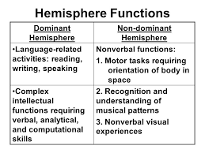

* Dominant (usually left), non-dominant (usually right)

**1.5 Influences on Behavior\***

Neurotransmitters

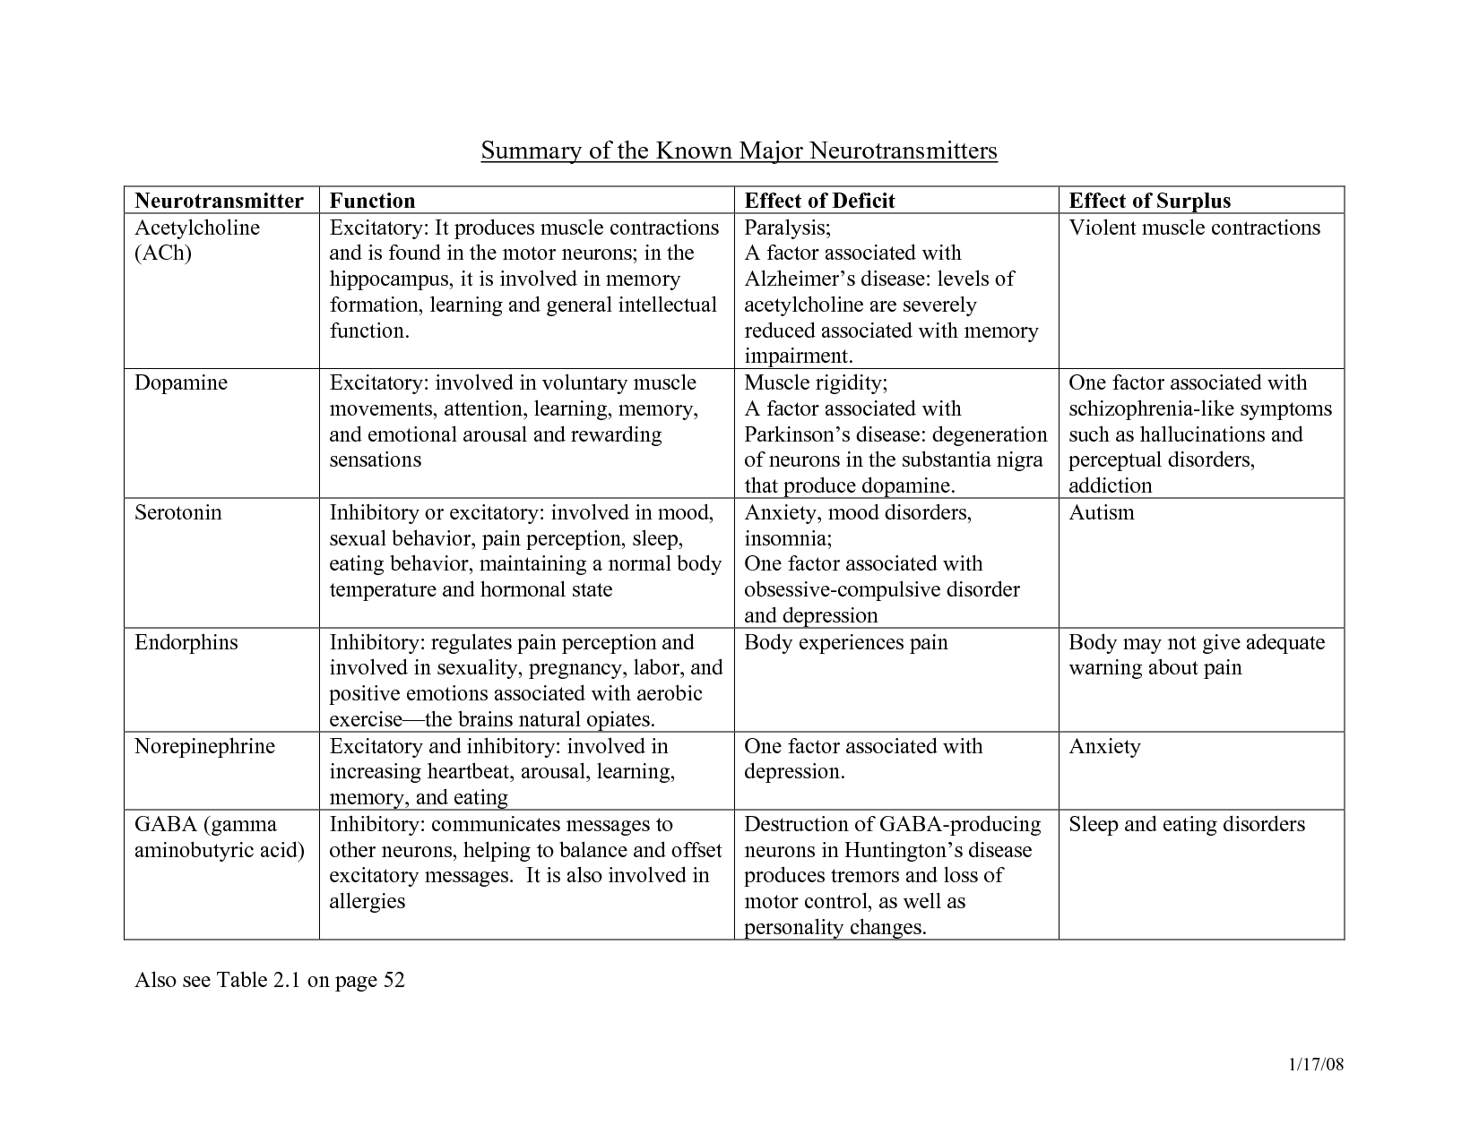

The Endocrine System

* The hypothalamus links the endocrine and nervous systems
* Refer to Biology Review: Chapter 5

Genetics and Behavior

* Nature (innate) vs Nurture (learned)
* Types of studies
  + Family studies: look at the relative frequency of a trait within a family compared to the general population
  + Twin studies: compare concordance rates between monozygotic (identical) and dizygotic (fraternal) twins
  + Adoption studies: compare similarities between adopted children and their adoptive parents, relative to similarities with their biological parents

**1.6 Development**

Prenatal

* Neurulation occurs

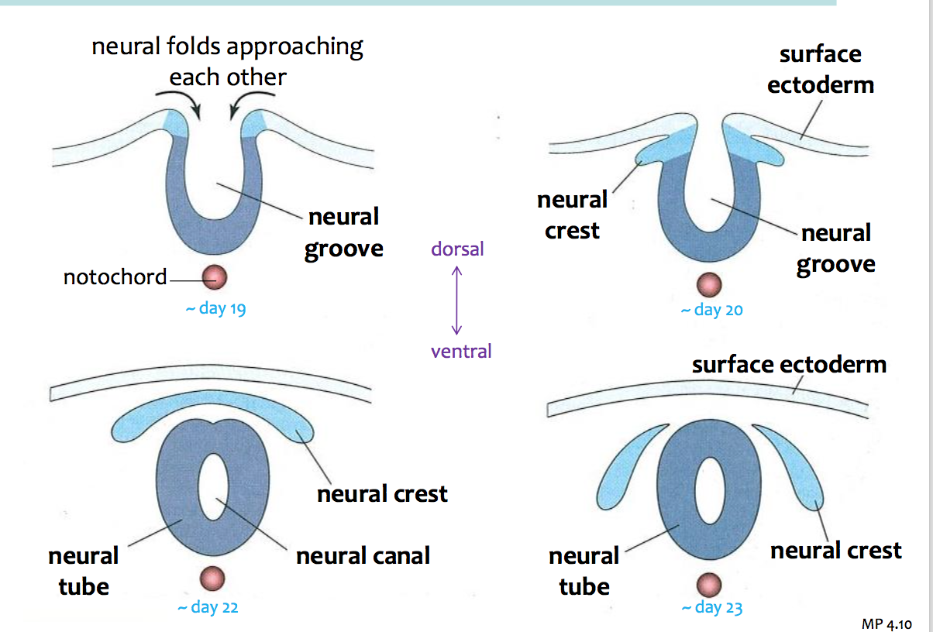

* Neural tube becomes the CNS
* Neural crest cells spread out throughout the body, differentiating into many different tissues including PNS
* Notochord becomes part of the vertebral column

Motor

* Primitive reflexes

1. Rooting reflex
   1. The infant turns his head toward anything that brushes the cheek
2. Moro reflex
   1. The infant extends the arms, then slowly retracts them and cries in response to a sensation of falling (triggered by abrupt movement of his head)
3. Babinski reflex
   1. The big toe is extended and the other toes fan in response to the brushing of the sole of the foot
4. Grasping reflex
   1. The infant grabs anything put into his hand

Social

* Developmental milestones (should deviate by only 1 or 2 months)
  + Gross and fine motor abilities progress head to toe, and core to periphery
  + Social skills shift from parent-oriented to self-oriented to other-oriented
  + Language skills become increasingly complex